FIRST PRESBYTERIAN CHURCH
Schaller, Iowa 10:00 A. M. July 17, 2022 Sixteenth Sunday in Ordinary Time
Rev. Michael Sydnor

PRELUDE Janice Ploeger, Organist
CANDLELIGHTING
WELCOME AND ANNOUNCEMENTS Elder
CALL TO WORSHIP: Elder
Elder: Christ is the image of the invisible God;
People: in him the fullness of God came to dwell.
Elder: Let us worship God!
*HYMN “O for a Thousand Tongues” #76
INVOCATION (Please be seated) Pastor
PRAYER OF CONFESSION (UNISON) Elder

We find it easier to talk than listen, and to do something than be still. Yet you call us to be still and know that I am God and that we need to do one thing: listen to Jesus. Forgive us for avoiding your call and failing to listen for your wisdom. Help us listen for your call that we might follow you to love God more deeply and our neighbor more generously. (Time of silent prayer) Amen.

ASSURANCE OF PARDON Pastor
*GLORIA PATRI #623

SCRIPTURE LESSON
First Reading: Amos 8:1-12 Elder
This is what the Sovereign Lord showed me: a basket of ripe fruit. “What do you see, Amos?” he asked. “A basket of ripe fruit,” I answered. Then the Lord said to me, “The time is ripe for my people Israel; I will spare them no longer. “In that day,” declares the Sovereign Lord, “the songs in the temple will turn to wailing. Many, many bodies—flung everywhere! Silence!” Hear this, you who trample the needy and do away with the poor of the land, saying, “When will the New Moon be over that we may sell grain, and the Sabbath be ended that we may market wheat?”— skimping on the measure, boosting the price and cheating with dishonest scales, buying the poor with silver and the needy for a pair of sandals, selling even the sweepings with the wheat. The Lord has sworn by himself, the Pride of Jacob: “I will never forget anything they have done. “Will not the land tremble for this, and all who live in it mourn? The whole land will rise like the Nile; it will be stirred up and then sink like the river of Egypt. “In that day,” declares the Sovereign Lord, “I will make the sun go down at noon and darken the earth in broad daylight. I will turn your religious festivals into mourning and all your singing into weeping. I will make all of you wear sackcloth and shave your heads. I will make that time like mourning for an only son and the end of it like a bitter day. “The days are coming,” declares the Sovereign Lord, “when I will send a famine through the land— not a famine of food or a thirst for water, but a famine of hearing the words of the Lord. People will stagger from sea to sea and wander from north to east, searching for the word of the Lord, but they will not find it.
Leader: The Word of the Lord.
People: Thanks be to God.

Gospel Lesson: Luke 10:38-42
As Jesus and his disciples were on their way, he came to a village where a woman named Martha opened her home to him. She had a sister called Mary, who sat at the Lord’s feet listening to what he said. But Martha was distracted by all the preparations that had to be made. She came to him and asked, “Lord, don’t you care that my sister has left me to do the work by myself? Tell her to help me!” “Martha, Martha,” the Lord answered, “you are worried and upset about many things, but few things are needed—or indeed only one. Mary has chosen what is better, and it will not be taken away from her.”
Leader: The Word of the Lord.
People: Thanks be to God.
CHILDRENS TIME
HYMN “Be Thou My Vision” #382
SERMON “You Don’t Have to Do a Thing!”
*APOSTLE’S CREED
MINUTE FOR MISSION
SHARING OF JOYS AND CONCERNS
Prayers of Intercession
The Lord’s Prayer
Congregational Response #421 (Verse 1)
PRESENTATION OF TITHES AND OFFERINGS
OFFERTORY
*DOXOLOGY #625
*PRAYER OF DEDICATION

SOMEONE IS THERE FOR YOU
Have You Ever Needed To Talk
To Someone
And There Wasn’t Anybody There?
I Have.
But What Some People Don’t
See Is,
There IS Someone There.
HE Has
Always Been There For You
And For Me.
And If You Look Deep Down
In Your Heart
You Will Find That HE Is There,
Waiting On
Your Call For Help.
So
Anytime You Feel Alone
Just Look.
Look Deep Down In Your
Heart
And You Will Feel Loved,
Safe And Strong.
Author: Elizabeth Smith Age: 12

*HYMN “More Love to Thee” #363
*BENEDICTION
*BENEDICTION SONG “Freely, Freely” (V. 1) #447
*EXTINGUISHING OF CANDLES
*POSTLUDE
(*Those who are able please stand.)

i2022 PER CAPITA

2022 Per Capita amount is $42.48. It is a very important way we can contribute to the operation and mission of the Presbyterian Church. Session encourages all members to contribute. Please mark your check “Per Capita”.

FOOD PANTRY
Reminder: When bringing food items for the food pantry, please check the expiration dates.

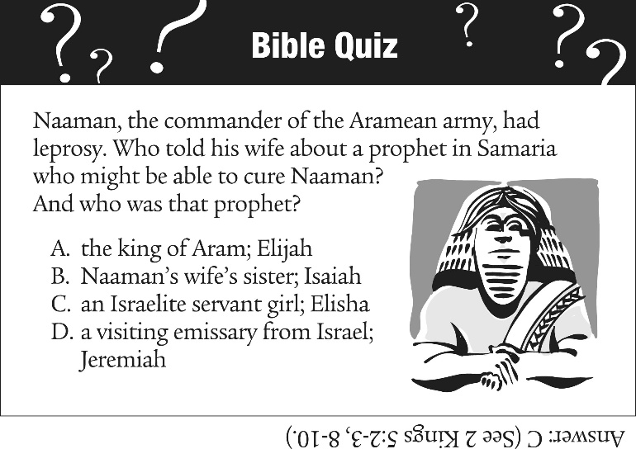
ANNOUNCEMENTS
July 2022
17 Sunday
10:00 am In-Person Worship in Sanctuary (Masks are optional)
18 Monday
7:00 pm Session Meeting
21 Thursday
7:00 pm Online Bible Devotional and Community Prayers
24 Sunday
10:00 am In-Person Worship in Sanctuary (Masks are optional)

VACATION BIBLE SCHOOL

Vacation Bible School will be August 1st through August 5th from 9 a.m. – 11:30 a.m. (8:30 a.m. on August 1st for registration.) ANY students going into Kindergarten through students who have completed 5th Grade are WELCOMED and ENCOURAGED to come!
This year’s theme is: Food Truck Party On A Roll With God!
VBS Registration, Health, and Covenant forms can be found in the brown information box by the Presbyterian Church’s Front Door.
Please fill out the forms and enclose them in the envelopes that are provided and put back in the information box. Take as many forms as you would like! The information box is checked daily.

NEW JOYS & CONCERNS:

CONTINUING JOYS AND CONCERNS:
Jim & Janet Illum
Dennis Miller (Cancer)
Dexter Meseck
Janet Schubert
Andy Beckord
Aaron Jacobson and his family
(Safe Deployment)
Tasha King (Safe Deployment)
Carissa King (Mission Work in Guatemala)
Doug O’Bannon & Shari O’Bannon
Dennis Pfrimmer
Hazel Snyder
Brenda Segebart

BIRTHDAY WISHES:
Eli Franken (July 19th)

ANNIVERSARY WISHES:
Jerry & Dee Gosch (July 17th)
CA & Terri Rininger (July 18th)
Dan & Theresa Bailey (July 28th)

Presbyterian Church. Book of Common Worship (p. 367). Presbyterian Publishing. Kindle Edition.

